Transformer-Based Electricity Consumption Forecasting Using Time-Series Data
MSML612 Interim Project Report
William Peng, Ciara Cameron, Christopher Pedretti

Data Preparation and Curation
This project uses the Individual Household Electric Power Consumption dataset, which contains approximately 2.1 million minute-level electricity measurements collected from a single household over a four-year period. The dataset includes global active power, global reactive power, voltage, current intensity, and three appliance-level sub-metering variables.
Before training the model, the dataset was preprocessed to improve data quality and prepare it for time-series forecasting. The Date and Time columns were combined into a single datetime field and used as the dataset index. All remaining columns were converted to numeric values, duplicate timestamps were removed, and missing values were handled during preprocessing. To reduce computational complexity while preserving overall consumption trends, the minute-level observations were resampled into hourly averages. The processed data was then split chronologically into training, validation, and testing sets to preserve the temporal nature of the data. Finally, the predictor variables and target variable were standardized using StandardScaler and sliding windows of 24 consecutive hours were created to generate the input sequences for the Transformer model.

Neural Network Design and Implementation
A custom Transformer model was implemented in PyTorch to forecast household electricity consumption using multivariate time-series data. Transformers use self-attention mechanisms to learn relationships across an entire input sequence rather than processing observations one step at a time. This makes the architecture well suited for time-series forecasting because it can capture both short-term and long-term temporal patterns in electricity consumption.

The model begins with a linear input projection layer that maps the seven input features into a higher-dimensional representation before applying positional encoding to preserve the temporal order of the sequence. The encoded inputs are then processed using two Transformer encoder layers with four attention heads, a feedforward dimension of 128, and a dropout rate of 0.1 to reduce overfitting. The final hidden representation is passed through a fully connected output layer to predict the next hour of global active power consumption. The model is trained using the Adam optimizer with Mean Squared Error (MSE) as the loss function.

Code Quality and Reproducibility
The project is organized into separate directories for the dataset, notebooks, saved models, figures, and reports to support collaboration and reproducibility. A README file documents the project structure and setup process, while a requirements file lists the required Python packages. Random seeds are fixed to improve reproducibility, and the notebook saves the trained model, preprocessing scalers, and prediction results so experiments can be reproduced without retraining the model.

Current Performance
The current implementation successfully trains the Transformer model and generates predictions on the testing dataset. Model performance is evaluated using Mean Absolute Error (MAE), Mean Squared Error (MSE), and Root Mean Squared Error (RMSE). The model currently achieves an MAE of 0.3208, an MSE of 0.2156, and an RMSE of 0.4643. These preliminary results indicate that the model is learning meaningful temporal patterns from the historical electricity consumption data.

Figure 1: Training and validation loss over 20 epochs
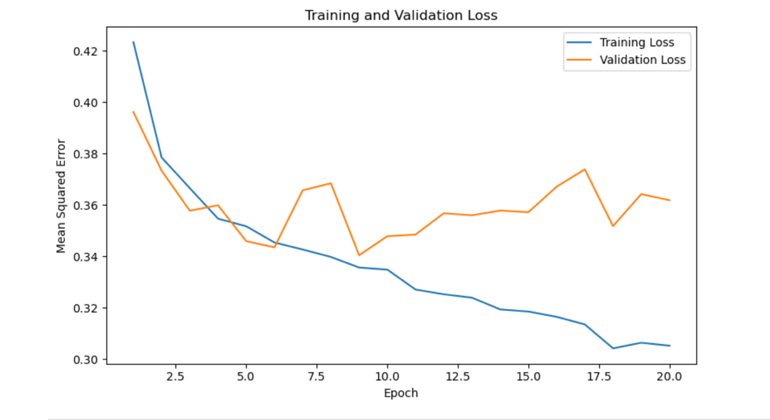

Figure 2: Actual vs. predicted global active power on the testing dataset
